Amanda Seifert
Augustana College
Amanda-seifert@augustana.edu

Uncle Ho’s Communist Goals

This paper examines political culture in Vietnam. More specifically, this paper explores the extent to which Vietnamese are committed to democratic norms and share attitudes closely aligned with communist ideology. Vietnam, in the mid 1980s, began to adopt market-based reforms and marketization and growing ties with the West have continued at a fairly rapid pace in the past two decades. Along with marketization Vietnam has very slowly been introducing political reforms, giving more power to and allowing independents to run for the National Assembly, opening up space for religious activities, and gradually removing some media censorship. Using data from the World Values Survey collected in 2001, I look at a number of questions to begin to determine if citizens in Vietnam are responding to these economic and political changes by adopting more democratic and market-oriented attitudes.

When most Americans hear the word Vietnam, the first thing that comes to mind is a war, draft cards, politicians, soldiers, and hippies. However, today Vietnam is a united communist nation and a vital trade partner rather than the ever-elusive enemy. Years have passed since the war, and as wounds have healed and towns rebuilt, Vietnam has established itself as a stable communist government. As generations have adjusted to the absence of war and come to prosper under this regime, it is likely that Vietnam’s political culture has changed. Considering this change, and the country’s unique stance as a communist nation, the question now is, what kind of political culture has Vietnam developed? Its political culture is shaped not only by war and history but also by its unique position as a communist nation.

One prominent political scientist defines political culture as “A people’s predominant beliefs, attitudes, values, ideals, sentiments, and evaluations about the political system of their country and the role of the self in that system” (Diamond 163). Political culture can also be defined as, “Public attitudes toward politics and their role within the political system” (Almond, et al. 56). These attitudes determine what the public expects from its government, such as, what type of government it will have and what policy it will put forth. Political culture can also help shape how active an individual is in the government, such as, voting for representatives or allowing them to be appointed. These beliefs are influenced by cultural aspects like religion, as well other factors like time. However, these beliefs are deep seeded and change is often slow. As Diamond points out, “Norms and values represent the most deeply embedded and enduring orientations toward political action and the political system”(163).

According to some, it is these beliefs that determine the type of government that will take hold within a country. As Diamond asserts, “A stereotype of political cultural theory sees in it a casual determinism, that political culture more or less predetermines both political structures and political behavior and that the elements of political culture are resistant to change” (164). The political culture of a nation should shape the type of government that will take hold, as well as the processes of that government.

Furthering this idea, political culture plays a role in whether or not a regime can be considered consolidated. Shin and Wells address the idea of consolidated democracy by asserting, “…Democratic consolidation is a multidimensional phenomenon involving the transformation of both political institutions and cultural values” (89). This means that for a nations government to be considered consolidated it needs to have both the system and the deep seeded cultural support for that system. In addition to having a culture in line with whatever system is in place, Shin and Wells also argue, “Citizens must show that they recognize democracy as ‘the only game in town’ – by not only accepting democracy, but also rejecting its alternatives” (89). Not only must political culture and regime align but people must reject all other forms of government, honoring their current form as what is best for themselves. This means that in order for democracy to be consolidated in a nation, people must vote and have all the other trappings of democracy, they must value and desire representation and participation in their political system, and they must also reject anything other than democracy as the best form of government for their nation.

Diamond and his co-authors put a standard on these values by claiming that if, “…a significant portion (i.e. a third or more) of public opinion doubts or rejects the legitimacy of democracy, then consolidation has yet to be achieved” (Diamond et al. 3). According to Diamond if 60 percent or more of the population does not have values that support democracy, than the nation in question does not have the political culture that allows for consolidated democracy. While these authors are addressing democracy, theoretically the same should hold true for communism. For a communist state to be considered consolidated it must have a communist culture. This would include valuing government regulation and the ability of the government to appoint officials rather than voting for them. Western thought would also be inclined to define such a culture as one that does not support democracy or democratic ideals. However, data from the World Values Survey shows that Vietnamese do in fact support values and ideas that appear democratic.

This highlights the concept that not all political beliefs can be clearly lumped into democratic or authoritarian. Vietnam’s political culture is shaped by a history of war and the modern day flow of globalization. Today, younger Vietnamese hold more democratic beliefs than older Vietnamese do. To many this means Vietnam in the future is likely to democratize. However, it is through a liberal market, that has produced significant economic progress, and controlling government policy that Vietnam will remain communist.

This paper will use the World Values Survey to test a series of hypotheses based on the twin ideas that a) a communist nation should exhibit attitudes among the public that are closely aligned with communist ideals and b) that marketization and (very) incremental political opening have also influenced public views. The World Values Survey is a collection of surveys conducted by social scientists all around the world since 1971. These surveys encompass social and political values of respondents. Questions vary from personal goals to goals of the government and beyond. Currently, survey data for Vietnam is only available for the year 2001; this makes comparison over time impossible. However, by viewing responses according to age it is possible to predict future answers as well as how experience has affected respondents’ answers. Viewing data in three different age groups: 15 - 29, 30-49, and 50 and over, allows a look at youth, middle age, and elderly. Each of these age groups has a unique set of experiences tied to the political and economic history that they have experienced.

It is important to note that the “American War,” as it is referred to by Vietnamese, occurred from roughly 1959 until 1975. This means that the respondents in the 15 – 29 age group were at the very most three years old when the war ended. This means they would not have witnessed much battle; they would have been raised in the aftermath of war and likely only remember Vietnam as one nation. The respondents in the 30 - 49 age group would have been at most 8 when conflict began in 1952 and 23 years old when it ended. Conversely, they may have only been four when the conflict ended. This creates quite a gap in experience. This should clearly affect responses and the numbers that are derived from them. The final group of 50 and over most clearly represent the group of respondents that were most affected by the war. This group more than likely fought in battles, lost friends and family members, and bore witness to the reunification of the nation under communism. Additionally these changes in opinion could be due to efforts on the part of the Vietnamese government to indoctrinate its citizens. Immediately after the war indoctrination was at an all time high with a plethora of propoganda and re-education camps. As time went one this indoctrination lessened with the practices of Doi Moi. With markets opening and private business becoming a common practice indoctrination lessened as citizens became active in business and Vietnam tried to create a more appealing image for foreign investors. This younger cohort should also have views that reflect the economic and, to a lesser extent, political changes that have taken place since the mid-1980s.

Hypothesis 1: For communism to be consolidated, Vietnamese should prefer a regulated society versus one that is deregulated – by a wide margin.

Hypothesis 2: For communism to be consolidated, Vietnamese will prefer business that is government owned versus privately owned business – again by a wide margin.

Hypothesis 3: The 15-29 age group will have responses that are far more liberal than that of the 30-49 and 50 and over age groups. However, the views of the younger generation should be more in tune with market-based economic principles than democratic, as economic changes have been much more intensively pursued than democratically-oriented political reforms.

To get a glimpse of what Vietnamese want for their nation and value in their government it is valuable to look at a question on regulation versus responsibility in society (See Figure 1). Respondents were asked to choose between, “A society that assures safety and stability through appropriate regulations,” and “A deregulated society where people are responsible for their own actions.” The 30 - 49 and 50 and over age groups both responded with roughly 50 percent of respondents in favor of a regulated society. Respondents in the 15 – 29 age group lagged by roughly five percent, but still maintaining a majority of responses in favor of a regulated society. This demonstrates that Vietnamese clearly favor a society where the government plays an active role in daily life. Citizens’ seeking regulation and control of daily life is a part of a political culture that supports communism. If Vietnamese citizens value the regulation they experience in society and their daily lives, it can be expected that whatever control and intervention the government provides will be supported in the future. This support will easily further the practice of communism in Vietnam.

However, while support for a regulated society maintains the simple majority, it is not unthreatened. Respondents in the 15-29 and 30-49 age group responded with roughly 24 percent each, in support of a responsible society. Could this mean that the future ruler’s of Vietnam are looking for a less regulated society? Possibly yes, possibly no. The original wording of the question does not specifically implicate government action. Therefore, it is possible for a respondent to view the question in solely social terms and hope that if citizens themselves became more responsible there would be less need for government regulation. This understanding of the question does not ask for less government involvement but rather a better citizen to serve the government. This again plays into communist culture with the belief as explained by Gabriel Almond, “The ideological political culture in every communist country posits an ideal communist man who is both the builder of the new society and a product of its institutions and practices” (132). Therefore, it is possible to believe that respondents were taking on their “builder” duty by hoping for a society in which Vietnam would thrive with better citizens that are themselves more responsible.

Overall, 49% of respondents supported regulated society with a following 12% claiming “somewhat closer” to regulated society than responsible society. Alone, the 49% is not really enough to raise constitute consolidation, however when combined with the 12% that at least prefers regulation to responsible society , it can be concieved that a considerable portion of Vietnamese do support this communist ideal. This percentage proves that a majority of respondents do value the government involvment in their daily lives, supporting the idea of consolidated communism in Vietnam.

Another question that provides information on Vietnam’s political culture, question ownership of business (See Figure 2). Respondents were asked to indicate how they felt about private versus government ownership of business and given a scale from one to ten, in which one represented “Private ownership of business should be increased” and ten represented “Government ownership of business should be increased.”

With the scale allowing twice as many possible answers as the previous question, responses were far more spread. The 15 – 29 age group responded with 15 percent of respondents wanting more privatized business and 10 percent wanting more government owned business. This shows only a small portion of respondents greatly desiring privatization - a democratic ideal - versus the communist ideal of government ownership. In the 30– 49 age group, only 14 percent wanted more privatization with 15 percent wanting more government ownership. This demonstrates a tie between the two extremes and serves to highlight the diversity of experience within this age group. The 50 and over age group had the most polarized responses with only 10 percent wanting more privatization and nearly 20 percent wanting more government owned business. Not surprisingly, the largest concentration of answers fell in the middle range, showing little or no preference for either way of business.

These responses are particularly interesting considering they verify most predictions about respondents. To begin with, the 20 percent of respondents 50 and over that would prefer more government ownership could be easily verified through experience. This age group contains people that were most affected by war and the transition of Vietnam to a communist state. Because communism in Vietnam - especially before Doi Moi - condemned and even outlawed private ownership, it is believable that this age group would prefer government ownership as it fits with both communist ideals and what respondents in this group are traditionally accustomed to. In the 30 - 49 age group, it is conceivable that there would be a split between the two ideals because there is quite a difference in experience with this age group, with a potential half of all respondents participating in the war and the other half growing up at the end of the war. Finally, the youngest group of 15-29 years of age favors privatization by nearly 5 percent. This response is likely because of the economic renovation policies of Doi Moi that privatized business and lead to sudden economic prosperity for Vietnam. This clearly shows Vietnam’s political culture at a crossroads. Citizens are unsure about a change back to government ownership of business, and a majority sees no need to change the system from where it is at today.

Looking at the respondents as a whole, 15% or less of respondents actually aligned with either privatized or government owned business, leaving a majority in the middle. This leaves no conceivable significant portion that either supports or denies the idea of government owned business. While it is valuable to consider the reasons behind this spread, ultimately the results indicate that respondents do not assertively support the communist value of government owned business. Ultimately through the mixed messages of indoctrination and the changes that occurred in Doi Moi, respondents are unsure about which form of business is most effective or best for their nation.

To test whether or not Vietnam has not only a political culture that supports communism, but that it is consolidated by rejecting any other form of government, a question on democracy was used (See Figure 3). Respondents were asked if having a democratic political system would be best for Vietnam based on a scale ranging from “Very Good” to “Very Bad.” The results are startling. All three age groups responded with over 50 percent in support of a democratic system as a “Very Good” system of government for their country. This is only ten percent shy of the roughly 60 percent that Diamond suggests, meaning communism is not consolidated.

Looking at the results in greater detail, the 50 and over age group stand out, with a whopping 65% in support of a democratic regime. Given the indoctrination and personal experience of this group, it is surprising that they support democracy so strongly. Presuming communism is consolidated in Vietnam, the 50 and over age group should have responded with the most support for communism by rejecting any form of government other than communism as the best for their nation. The 30-49 age group is not far behind with 58% in support of a democratic regime. These two groups could reasonably be seen as the “significant portion” Diamond addresses, drawing the conclusion that communism in Vietnam is not consolidated. The youngest group of 15-29 has the smallest percentage in support of a democratic regime totaling only 53%, the least of the three groups. Even this somewhat lower number is not far from 60%. Out of the three groups, it is surprising that the youngest and supposedly most liberal generation is actually the least in support of a democratic regime.

Overall 59% of respondents said democracy would be a “Very Good” political system for Vietnam, and 37% percent said it would be “Fairly Good.” The portion of respondents claiming democracy would be “Very Good” are almost enough to say that communism is clearly not consolidated in Vietnam. However, the percentage claiming it would be “Fairly Good” clearly assert that Vietnamese do not believe that communism is the best and only form of government for their nation.

Hypothesis 1 is confirmed with a combined 61% at least preferring a regulated society to a responsible society.

Hypothesis 2 is refuted as only a small majority chose government owned business over privatized business.

Hypothesis 3 is confirmed as more youth support privatized business over government business, although this is not by a wide margin. Furthermore, the 15-29 age group shows the least support for democracy confirming that most reforms have been economic and democratically based.

This leads to a conclusion that through Vietnam’s privatization policies it has experienced economic growth that many outsiders predict will cause a future move to democracy. However, it is possible that through this prospering economy, Vietnam will become a state of dual policies: liberalization in the marketplace and a communist government policy. This is confirmed through its youth, which support privatized business, and near rejection of democracy. In addition to its economic prosperity, as Vietnam continues to step into the international scene, globalization will also present the country with new challenges. As Brintnall explains in his article on a visit to Vietnam, “The regime faces political change with obvious reluctance.” Additionally there is a notable, “worry about socializing a postwar generation of youth into support for the political regime” (628). The biggest struggle will be adapting the democratic ideas that permeate western media into communist friendly terms. The ideal situation would be to interpret these messages in ways that will actually reinforce communist political culture. Ultimately, Vietnam may not yet have consolidated communism but depending on the steps it takes, the current generation of youth may breed a future of consolidation. However, it must be cautioned that these speculations are made from a very limited set of data. To truly predict the future of communism consolidated or otherwise in Vietnam a much wider base of data with comparison over time would be needed.
Figure 1 : Graph of Society Aimed at Regulated vs. Responsible Society
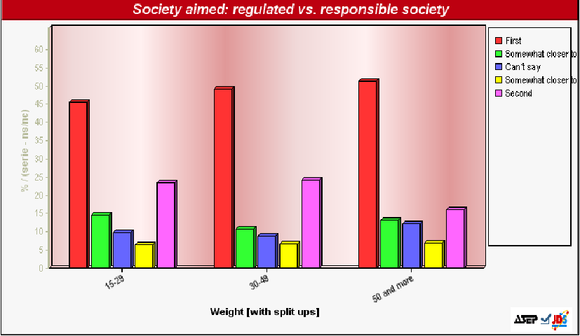

Figure 2 : Graph of Private versus State Ownership of Business
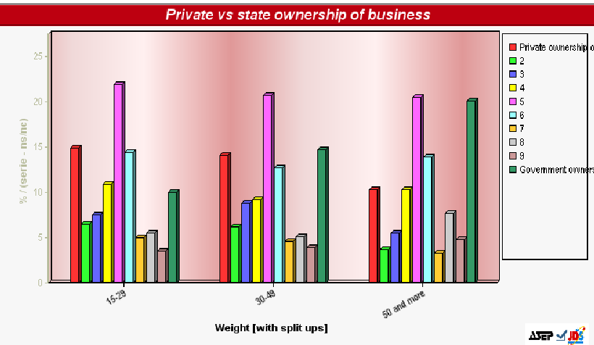
Figure 3 : Having a Democractic Political System
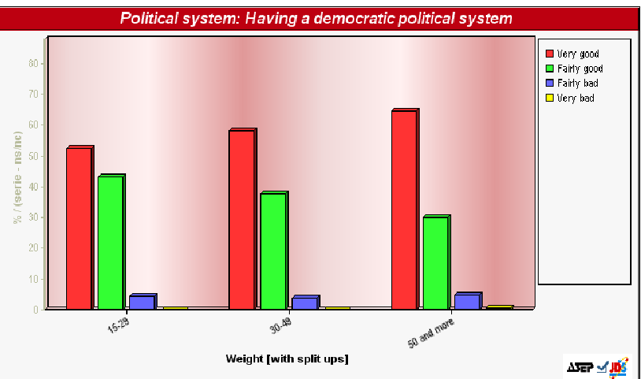
Works Cited
Almond, Gabriel A. “Communism and Political Culture Theory.” Comparative Politics, Vol. 15, No. 2 (Jan., 1983), pp. 127-138. J-Stor. 16 Dec. 2008. <http://www.jstor.org/stable/421672 >.
Almond, Gabriel A. et al. Comparative Politics: A Theoretical Framework, 3rd Ed. New York: Longman, 2001.
Brintnall, Michael. “A Political Scientist Returns to Vietnam.” PS: Political Science and Politics, Vol. 27, No.3 (Sep.,1994), pp. 628-633. J-Stor. 16 Dec.2008. <http://www.jstor.org/stable/420231 >.
Diamond, Larry, Jonathan Hartlyn, Juan J. Linz, and Seymour Martin Lipset. Democracy in Developing Countries: Latin America. 2nd Ed. Boulder: Lynne Rienner Publishers, Inc., 1999.
Diamond, Larry. Developing Democracy Toward Consolidation. Baltimore: Johns Hopkins University Press, 1999.
Shin, Doh Chull, and Jason Wells. “Challenge and Change in East Asia: Is Democracy the Only Game in Town?” Journal of Democracy, Vol. 16, No. 12 (Apr., 2005). pp. 88-101.

