The Lasting Impact of French Colonialism in Haiti
Greg Lyons
Monmouth College
Abstract
What impact did French involvement in Haiti have on the current economic situation in the island nation? Haiti has struggled to improve its struggling socio-economic problems since the period of French colonialism starting in the early 1600’s (Robinson, 2007). Most of the problems can be linked to environmental degradation caused by the profit first environment last mentality of the French settlers (Ventre, 2008).
I posit that the reason the French were more careless towards the environment of Haiti than other colonies, specifically those in Indochina, for two reasons. First being that during the colonial control of Haiti the French government was interested in gaining wealth by any means possible (such as clear cutting and the use of slave labor) and because of this they cared very little about the lasting effects of their abuse of natural resources. Secondly being there was relatively little knowledge of the long term effects of environmental destruction between 1600 and 1700, something that was far more apparent during the first half of the 20th century when the French controlled Indochinese territories. Other less substantial factors include the differences in government structures in France, being a monarchy during the period of control of Haiti and a “Democratic” Republic during the early 1900’s when the country controlled various territories in Indochina. Further the growing global economy and the responsibilities included with managing an empire, along with trouble France (proper) could have led to less concern over gaining wealth from their colonial holdings abroad.
This paper adds to the understanding of French colonialism by suggesting new reasons for the creation and holding of colonies around the globe for the French government. Further it lays a new groundwork for understanding the dire situation in Haiti today due, directly, to the colonization of the island by the French throughout the 17th century.
Introduction
The countries that occupy the Caribbean island of Hispaniola have had a turbulent history dating back to 1492 when the island was first discovered and colonized by the Spanish. This essay examines how colonial control, specifically the use of natural resources, has had lasting effects on both Haiti and Dominican Republic. It is the lumber and mining trade that is of major concern and is a main source of the economic hardships that Haiti faces today.
Further the essay examines whether the impact of French rule was unique to Haiti or if other French colonies suffered similar fates. Also it looks at how issues today are affecting the two nations, and how these issues have created such disparity between two nations that share one island. Dominican Republic is a nation that has worked through its struggles and has had some success in recent times, while Haiti has continued to struggle with numerous problems and is the poorest country in the Western Hemisphere.
During the 100 years of French rule, Haiti was one of the wealthiest colonies in the world, due in large part to the booming sugar, mining and lumber trade. The French colonial powers used their knowledge and also slave labor to mine and clear cut the forests very efficiently. Because of this Haiti was a major trading asset to the French government, as the colony was not only sending supplies back to France but also was used to supply British and Spanish colonies in the region.
The French rulers were interested in making as much money as possible in a short period of time and because of this the practices employed by the French were, at best, irresponsible. Strip mining for resources and clear cutting the lush forests of Haiti have had lasting effects on the country. Problems facing Haiti today range from agricultural to water purification. Due to the loss of forested areas in Haiti, farmers have had to deal with nutrient decay, mudslides and landslides during heavy storms and also because of the wash away effect of the land itself water quality has suffered heavily. While some of this is due to natural erosion, the integrity of the land would be much better if there were forests to protect the land. The roots of the trees would aid in keeping the land secure and also in the natural process of nutrient management.

Background on Hispaniola and Colonialism
The island of Hispaniola is located between Cuba and Puerto Rico; the island is the home of two countries, Haiti, which controls the Western third of the island, and Dominican Republic which controls the Eastern two-thirds. The island was “discovered” by Christopher Columbus in 1492 on his voyage to the New World. Shortly after landing the Spanish took control of the island and within 25 years the native Tainos were essentially wiped out by the Spanish settlers and replaced with huge numbers of slaves imported from Africa. Slaves provided cheap labor for the agricultural and industrial motives of the Spanish settlers. Starting in the early 1600’s the French came to Hispaniola in an attempt to further expand their colonial power and also to gain access to the materials available on the island (lumber and minerals), following a brief period of both Spanish and French rule Spain ceded control of the Western third of the island to France in 1697. The French controlled the island for over 100 years before a massive uprising by the slaves on the island led to the Western third of the island, which is now know as Haiti, gained independence.
This uprising was a major change in global politics, as Haiti was the first black republic to declare independence: “Such was the staggering global significance of the only successful slave revolt ever mounted in the Americas”. After Haiti gained independence from the French the Western two thirds of the island, known as Santo Domingo, also sought to gain independence. However the Haitians, in an attempt to unite the entire island, conquered the rest of the Island and controlled it for the next 22 years.

French Colonialism in Indochina
Mark Cleary (2005) looks at the impact of French colonialism in Indochina from 1900 to 1940. During this time period the French colonial control of the region had great impact on the environment. “The relationship between science, scientific forestry and colonial policy in Britain, France and Germany grew from a preoccupation with indigenous exploitation…[imposing] more damage on the forests.”
Cleary states that one of the most important aspects of French colonialism was “rooted in…the drive for profit through resource exploitation.” The French, along with all colonial powers, had a specific goal for their colonies which was to make as much money as possible regardless of the costs to the indigenous population. Looking at Haiti’s situation during and after French colonial control it is clear that the French were more concerned with profits than the future of the lands they colonized, perhaps because the French people could simply leave the colonies and go home after the land was destroyed and the resources drained. This is a potential explanation for the huge difference in the Haitian economy from the early colonial days (when it was a very wealthy nation) to its current state as the poorest nation in the Western hemisphere (a change which occurred rather quickly after the nation gained independence).
Notably different was the Spanish venture on the island. The Spanish settlers were more interested in the gold they could mine from the land to expand their wealth as a nation than they were in lumber and sugar trade. Unlike the French, the Spanish settlers did not clear cut the island and were less irresponsible in their mining techniques. One possible explanation to this was the amount of time the Spanish were in control of the colony compared to the century of French rule. Had the Spanish controlled the island longer they may have developed the destructive techniques used by the French. Unfortunately the Spanish are in some ways directly responsible for the current situation in Haiti. The slave trade was started by the Spanish settlers and they also gave the island to the French. Because of this the French were allowed free reign over the Haiti which they stripped clear of natural resources leading to the struggles the nation faces today.
Cleary states that closer to 1940 the French began adopting policies to protect forests and farmers from this sort of exploitation. These policies clearly laid out definitions and guidelines for forestry and also for farming. An additional problem in Indochina was that farmers and ranchers were clearing forested areas to make room for more crops and livestock. The new policies gave greater protection to the forests and also more rights to farmers in regards to land ownership.
One of the most important aspects to making the people of Indochina understand that the forests need protection was through education programs. These programs educate the farmers and loggers on responsible use of the resources their countries hold, and also the importance of the forests in terms of effective agriculture, sustainable forestry and water purification.

Other Factors that have impacted Haiti
Haiti was further set back by the events of World War I. The United States, concerned about Germany’s spreading influence, established control of the nation in 1915. This occupation force further damaged the already frail Haitian economy, government and environment. The United States created infrastructure however in doing so they damaged the environment that was left in shambles by the French and worse yet they took complete control of the Haitian government. Doing so crippled the ability of the Haitian leaders to actually govern and hence set the young government back drastically.
Many other events have had a lasting impact on Haiti after the end of French colonial rule. The United States played an important role in Haiti soon after it gained independence. Due to the instability on the island and World War I the United States sent an occupation force to Haiti in 1915. The occupation force controlled Haiti until 1934. “There was good reason to believe in the years 1913-1914 Germany was ready to go to great lengths to secure the exclusive customs control of Haiti, and also to secure a coaling station at Mole St. Nicholas.” The United States felt that Germany was a direct threat to gain control of Haiti due to the instability within the government. If Germany had gained control of the island it would have posed a large threat to not only the United States but also Mexico, Cuba, Canada and other Caribbean nations. During this time period the United States had helped the country with several infrastructure projects that helped improve the island. However it was also during this time that huge numbers of Haitians suffered from human rights violations and continued widespread poverty. The United States officials had total control of the government of Haiti:
Representatives from the United States wielded veto power over all governmental decisions in Haiti, and Marine Corps commanders served as administrators in the provinces. Local institutions, however, continued to be run by the Haitians, as was required under policies put in place during the presidency of Woodrow Wilson. In line with these policies, Admiral William Caperton, the initial commander of United States forces, instructed Bobo [a candidate who was hostile towards the United States and an opponent of U.S. control of Haiti] to refrain from offering himself to the legislature as a presidential candidate. Phillippe Sudre Dartiguenave, the mulatto president of the Senate, agreed to and accepted the presidency of Haiti after several other candidates had refused on principal.

The people of Haiti were disgruntled by the control of the country by an outside entity. There were several uprisings by the local populations against the occupation forces. The people of the country were outraged by the inability of their government to make decisions for the country. The United States insisted that they were helping to stabilize the country by citing the political turmoil before their arrival:
The disorders to which Haiti has been subject since the achievement of its independence attained such destructive frequency during the last decade before the American intervention in 1915, that in the space of 10 years no less than eight presidents assumed office (it would be a mistake to say that they were elected) for the nominal constitutional term of 7 years each. Three of the eight fled the country; one was blown up in the presidential palace; another died mysteriously, and according to popular belief by poison, while two were murdered.

Despite political pressure to end the occupation after the end of World War I, the United States did not withdraw until 1934. “As in other countries occupied by the United States in the early twentieth century, the local military was often the only cohesive and effective institution left in the wake of withdrawal”. One positive affect of the occupation could be seen in the much improved infrastructure that the United States military built while on the island. However, other than the improved infrastructure the country was left in chaos and ruin when the occupation finally ended.

Postcolonial Haiti
Haiti has suffered much unrest and instability since gaining independence (before and after the United States occupation). Political violence, in the form of armed rebellions and guerilla attacks on government officials has been a never-ending issue for the nation. Haiti approved its first constitution in March 1987 however it was suspended in June of 1988, and many articles were reinstated in March of 1989. Violence erupted and the Constitutional government was removed from power by a military coup in September of 1991. The military government that took power after the coup claimed to be following the constitution however many people were disgruntled by the military rule. The military rule claimed to be constitutional; however it would only follow the constitution if it was congruent to the leader’s wishes. Much of the population was living in poverty and the government was doing very little to help them in the struggle. Also the people were upset by the fact that the military government was supposed to be transitional however it took many years before the government was willing to re-establish democratic rule and give up its power.
Constitutional rule was re-established in late 1994, and was in place until President Aristide was ousted by an armed military rebellion in February of 2004. After the rebellion the United Nations Stabilization Mission in Haiti helped lead the way for an interim government to be put in place and organize new elections. During this period of interim government rule the constitution was in effect but not being enforced (once again the constitution was only being upheld if it was convenient for the leaders. Finally in May 2006 constitutional rule was once again returned to Haiti as the people democratically elected President Preval and a parliament.
This sort of instability has created many other problems that are related to the poverty and hardship that the country is struggling. One of the biggest struggles of all developing nations is the lack of growth in the business sectors. Haiti is no different due in large part to the instability of the government and the high level of entrance barriers. “Countries such as Haiti which, through colonialism, inherited laws from the French legal system are especially prone to red tape.” Compared to the Common Law system adopted by many of Britain’s colonies, the French legal system tends to be more involved in business and such it is very difficult for entrepreneurs to start a business in Haiti. “In Haiti, one of the world’s poorest, prospective business people have to wait an average of 203 days for permission to start trading. Then they have to pay registration costs and satisfy minimum capital requirements of around four times the average Haitian’s annual income.” Because of these challenges to entrepreneurs, the industries where most of the population can actually find a job and make money are in logging, mining and farming. Further, because of the fact that people are being forced to work in these industries it is difficult to try and get the people to be concerned about the environment. The legal system along with the regulatory system of the economy in Haiti has created a cyclical situation where the people know they need to take care of the environment if they are to have a better life, however due to the incredible difficulty in starting a business outside of logging or mining they have no choice but to continue to devastate the natural resources of the land. Much of this has to do with corruption and greed by top government officials, but also has some ties to the long period of French colonialism where this system was born.
More importantly is the fact that even if there are effective education programs to teach individuals about the importance of conservation and sustainable forestry the people will not respond if they do not see the profit in changing their lifestyles. People have to provide for their families and in much of Haiti the only way to accomplish this is to work at logging camps or strip mines. The government has started several programs to stop irresponsible logging or mining practices, however due to lack of funding and corruption in the government the enforcement of these programs has been lacking. However there has been progress made to put the responsibility of the environment into the people’s hand and take it away from the government. “The spirit of the law is largely the same today (no cutting allowed without a permit), but the agents charged with enforcing it now answer to the civilian bureaucracy.” The importance of a civilian institution taking responsibility for the environment is that people will respond more favorably to their peers saying that irresponsible logging is bad as opposed to an oppressive and corrupt government. Another benefit of making civilians responsible for protection and preservation of forests in Haiti is that it develops a sense of self pride for the people in doing so. By making sure that the people feel a need to preserve the forests the people will take more of an interest in making sure that the environment is healthy which will improve their lives. Another benefit is that the disorganized and unstable government does not have the ability to bog down the process in red-tape.

Economic Situation of Haiti and Dominican Republic
Haiti and the Dominican Republic are both impoverished, however comparatively speaking Dominican Republic is leagues ahead of Haiti economically. Haiti is the poorest country in the Western Hemisphere, nearly 80% of its 9 million citizens live below the poverty line. Haiti has a GDP of $5.953 billion and a per capita GDP of $1,800. GDP real growth rates are estimated to be about 2.3%. Estimates show that roughly 63% of the population is unemployed. Most of the population lives off of subsistence farming producing little to no income. Haiti also suffers from high inflation rates of 14.4% as of 2006. The budget of Haiti shows $385 million in revenue and $807 million in expenditures for the year 2006. Haiti also has an estimated $1.3 billion in external debt.
Dominican Republic is much more economically stable with a GDP of $20.55 billion and a per capita GDP of $8,400. GDP real growth rates are estimated at 10.7%. Dominican Republic has an unemployment rate of about 16% and roughly 25% of the population lives below the poverty line. Dominican Republic has an inflation rate of 8.2% and has $8.634 billion in external debt. The budget for the year 2006 shows $5.852 billion in revenue and $5.947 in expenditures.
SEE APPENDIX A
Cambodia, one of France’s colonies in Indochina has a GDP of $8.604 billion and a per capita GDP of $1,900 and GDP real growth rates are estimated to be 10.1%. One striking difference between Cambodia and Haiti/Dominican Republic is the unemployment rate, which is only 2.5%. Similarly, Laos (another of France’s colonies in Indochina) has a GDP of $4.028 billion and a per capita GDP of $2,000 and a real growth rate of 7.5%. Also similar is the low unemployment rate of 2.4%.
Peru on the other hand was colonized by Spain is far better off than the aforementioned French colonies. Peru has a GDP of $109.1 billion and a per capita GDP of $7,600 and real growth rates are estimated at 9%. Unemployment in Peru is estimated at 6.9%. These numbers are not great, however compared to the French colonies studied they are far better.
Methods
This essay examined various cases of French Colonialism throughout history; Starting with the early holdings of Haiti and eventually Dominican Republic in the 17th and 18th century and moving to the late 19th and early 20th century holdings in Indochina (namely Cambodia and Laos). The cases have similar histories and are also similar in climate and population. For a reference point a former Spanish colony’s current economic situation was studied, Peru which was a Spanish colony and is similar both geographically and demographically was chosen for this purpose.
These cases represent countries that have incredibly similar histories with France, only differentiated by the time when France was in control. Peru represents is also nearly the same in size, population and geographic location however is differentiated by the fact that Spain rather than France held colonial power over the country for a period of time.

Findings
It is clear that Haiti is far worse off than Dominican Republic, Cambodia and Laos. However it is also clear that all of the French colonies studied are much worse off than Peru, which was a Spanish colony. The irresponsible habits of the French in their colonies not only on the island of Hispaniola but also in Indochina indicate that it was a habit of the country to exploit the resources of their colonies in an attempt to make the most profit possible.
Also when looking at other French colonies, such as Cambodia and Laos, that today they look very similar economically. However the French were not as hard on the environment in their Indochina holdings as they were in Haiti. Two possible reasons exist for this difference. First is that during the 1600 and 1700’s the French were more concerned about making as much profit from their colonial holdings, much like all colonial powers, and in order to compete and gain wealth quickly they had to work without regard for the environment.
Secondly is the fact that much less was known about the affects of environmental degradation during the 17th and 18th century, whereas in the late 19th and early 20th century more information was available on the potential harm that could come from the destruction of the environment. This expanded knowledge base may have led France to be more concerned with the environmental well being of its colonial holdings abroad.
There are other factors as well, namely the difference in government structure in France: Monarchy during the possession of Haiti and Republic during the days of their holdings in Indochina. A more important factor here could also be that during the early to mid 1900’s the global economy was growing quickly, especially as time nears the 1940’s and 50’s. People around the world were hearing about news from every corner of the earth. This created a sense of responsibility for the various colonial powers to treat their colonies well. This along with the new awareness of environmental issues led France to be more environmentally friendly in Indochina compared to their actions in Haiti.

Conclusions
The countries of Haiti and Dominican Republic have both suffered a great number of struggles during their long histories. When the island was “discovered” by Columbus in 1492 the indigenous people faced intense persecution and enslavement for the benefit of Spain and soon they were subjected to similar treatment by the French. Worse still was the systematic elimination of the Tainos to make way for slaves to be brought to the island further damaged the nation from the outset. Upon gaining independence Haiti struggled with political turmoil and instability along with widespread poverty. Much of this poverty could be due to the irresponsible use of the natural resources by the French colonial powers, not only in Haiti but also in Indochina. Haiti’s lush forests were clear-cut by the colonial settlers to make way for development. This troubled past has made it difficult for Haitians to move forward and gain success.
Dominican Republic, conversely, fought through its hardships and has come out better off for it. The people fought for democracy and after some struggle and instability have maintained a “more democratic” society than their neighbors. Political leaders have fought to provide jobs and increase economic activity. Because of these efforts Dominican Republic has had success where Haiti has failed. Dominican Republic’s government is far less involved in the private business sector, along with the fact that much of the forests on Dominican Republic’s land were not destroyed. Haiti on the other hand has a very oppressive government, especially in the private business sector and was at a disadvantage due to the destruction of natural resources by the French settlers. Should Dominican Republic continue on the track they are on growth should continue and the country could begin to prosper even more. Haiti on the other hand needs to focus on consistently improving and making positive, constructive changes if it is to pull out of the state of perpetual poverty that has plagued the country for the past century.

References

Buck-Morss, Susan. "Hegel and Haiti." Critical Inquiry 26, no. 4 (Summer 2000): 821-865. http://www.jstor.org/stable/1344322 (accessed October 7, 2008).

Cleary, Mark. "Valuing the Tropics: Dicourses of Development in the Farm and Forest Sectors of French IndoChina, circa 1900-40." Singapore Journal of Tropical Geography 26, no. 3 (Fall 2005): 359-374. http://www.jstor.org (accessed October 7, 2008).

CIA World Factbook, "Cambodia," 2008. https://www.cia.gov/library/publications/the-world-factbook/

CIA World Factbook, "Dominican Republic," 2008. https://www.cia.gov/library/publications/the-world-factbook/

CIA World Factbook, "Haiti," 2008. https://www.cia.gov/library/publications/the-world-factbook/

CIA World Factbook, "Laos," 2008. https://www.cia.gov/library/publications/the-world-factbook/

CIA World Factbook, "Peru," 2008. https://www.cia.gov/library/publications/the-world-factbook/

Department of the United States Navy. US Occupation of Haiti 1915-1934. 18 July 2005 Naval Historical Center. www.history.navy.mil/library/online/haiti_main.htm (accessed October 7, 2008).

Dupuy, Alex. "Spanish Colonialism and the Origin of Underdevelopment in Haiti." Latin American Perspectives 3, no. 2 (Spring 1976): 5-29. http://www.jstor.org/stable/2633510 (accessed October 7, 2008).

Economist, "Poverty's Chains," October 11, 2003. http://web.ebscohost.com (accessed October 7, 2008).

Gerring, John. Case Study Research. Cambridge University Press, 2007.

Jong, Lammert de, ed. Extended Statehood in the Caribbean: Paradoxes of Quasi Colonialism, Local Autonomy and Extended Statehood in the USA, French, Dutch and British Caribbean. N.p.: n.p., 2005.

Robinson, Randall. An Unbroken Agony: Haiti, from Revolution to the Kidnapping of a President. 2007.

"The Occupation of Haiti." Global Security. http://www.globalsecurity.org (accessed October 7, 2008).

Ventre, Tommy. "Planting Hope on Hispaniola." World Watch 21, no. 1 (January-February 2008): 8-13. http://web.ebscohost.com/ehost (accessed October 7, 2008).

Appendix A
All data in this appendix is from the CIA World Factbook

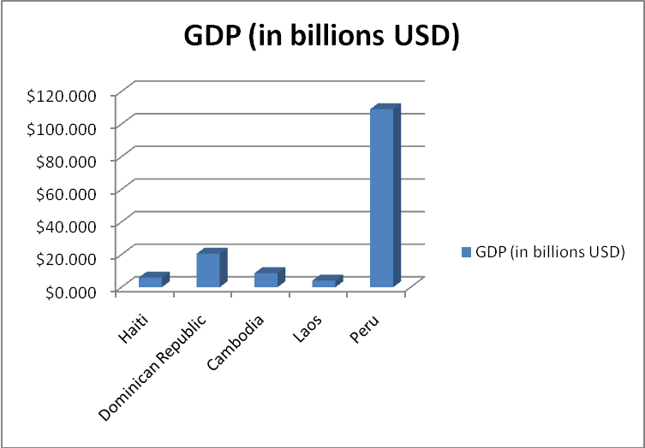

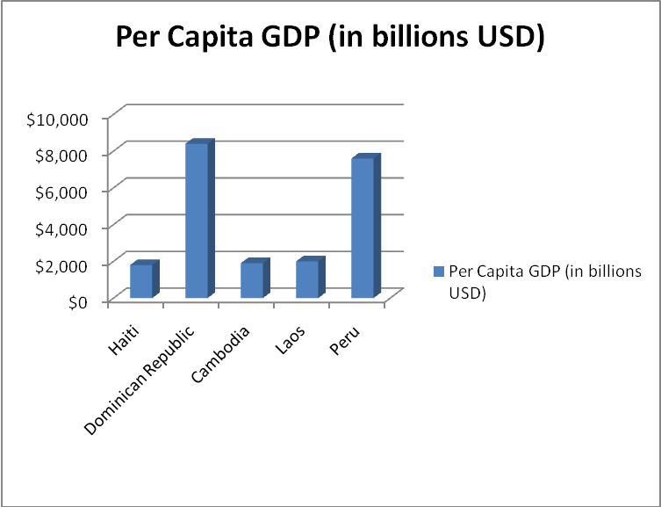

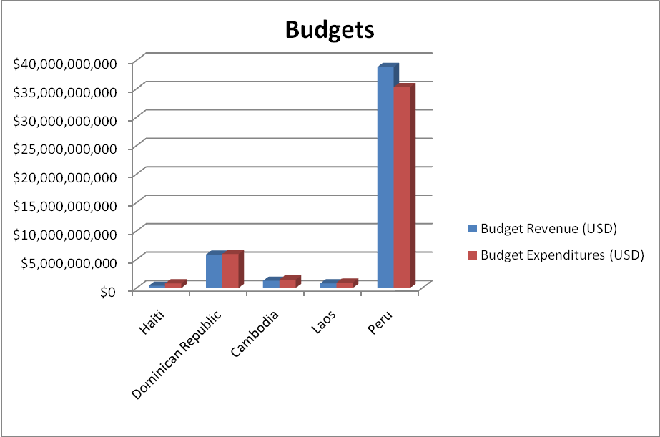

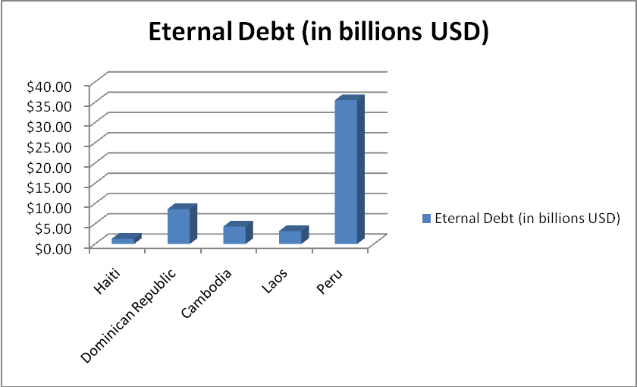

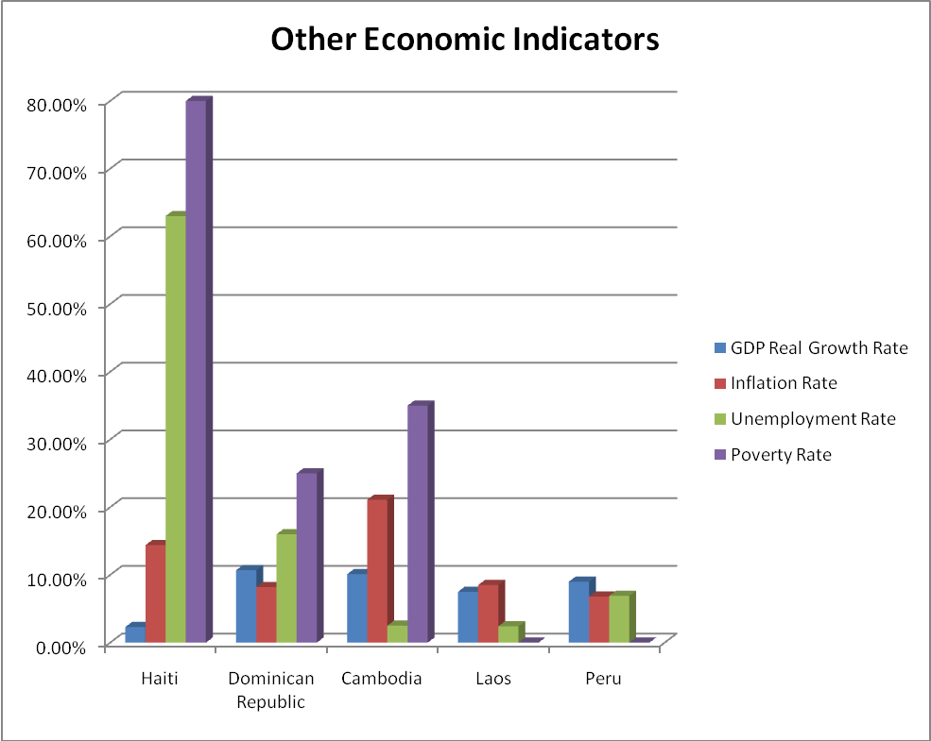
*Poverty Rates for Laos and Peru were unavailable

Robinson, Randall. An Unbroken Agony: Haiti, from Revolution to the Kidnapping of a President. 2007.
Robinson, Randall. An Unbroken Agony: Haiti, from Revolution to the Kidnapping of a President. 2007.
Ventre, Tommy. "Planting Hope on Hispaniola." World Watch 21, no. 1 (January-February 2008): 8-13.
Robinson, Randall. An Unbroken Agony: Haiti, from Revolution to the Kidnapping of a President. 2007.
CIA World Factbook, "Haiti," 2008. https://www.cia.gov/library/publications/the-world-factbook/
Robinson, Randall. An Unbroken Agony: Haiti, from Revolution to the Kidnapping of a President. 2007.
CIA World Factbook, "Dominican Republic," 2008. https://www.cia.gov/library/publications/the-world-factbook/
Cleary, Mark. "Valuing the Tropics: Dicourses of Development in the Farm and Forest Sectors of French IndoChina, circa 1900-40." Singapore Journal of Tropical Geography 26, no. 3 (Fall 2005): 359-374. http://www.jstor.org (accessed October 7, 2008).
Cleary, Mark. "Valuing the Tropics: Dicourses of Development in the Farm and Forest Sectors of French IndoChina, circa 1900-40." Singapore Journal of Tropical Geography 26, no. 3 (Fall 2005): 359-374. http://www.jstor.org (accessed October 7, 2008).
Dupuy, Alex. “Spanish Colonialism and the Origin of Underdevelopment in Haiti.” Latin American Perspectives 3, no.2 (Spring 1976): 5-29.
Cleary, Mark. "Valuing the Tropics: Dicourses of Development in the Farm and Forest Sectors of French IndoChina, circa 1900-40." Singapore Journal of Tropical Geography 26, no. 3 (Fall 2005): 359-374. http://www.jstor.org (accessed October 7, 2008).
Department of the United States Navy. US Occupation of Haiti 1915-1934. 18 July 2005 Naval Historical Center. www.history.navy.mil/library/online/haiti_main.htm (accessed October 7, 2008).
"The Occupation of Haiti." Global Security. http://www.globalsecurity.org (accessed October 7, 2008).
Department of the United States Navy. US Occupation of Haiti 1915-1934. 18 July 2005 Naval Historical Center. www.history.navy.mil/library/online/haiti_main.htm (accessed October 7, 2008).
"The Occupation of Haiti." Global Security. http://www.globalsecurity.org (accessed October 7, 2008).
CIA World Factbook, "Haiti," 2008. https://www.cia.gov/library/publications/the-world-factbook/
Economist, "Poverty's Chains," October 11, 2003. http://web.ebscohost.com (accessed October 7, 2008).
Economist, "Poverty's Chains," October 11, 2003. http://web.ebscohost.com (accessed October 7, 2008).
Ventre, Tommy. "Planting Hope on Hispaniola." World Watch 21, no. 1 (January-February 2008): 8-13. http://web.ebscohost.com/ehost (accessed October 7, 2008).
Ventre, Tommy. "Planting Hope on Hispaniola." World Watch 21, no. 1 (January-February 2008): 8-13. http://web.ebscohost.com/ehost (accessed October 7, 2008).
CIA World Factbook, "Haiti," 2008. https://www.cia.gov/library/publications/the-world-factbook/
CIA World Factbook, "Dominican Republic," 2008. https://www.cia.gov/library/publications/the-world-factbook/
CIA World Factbook, "Cambodia," 2008. https://www.cia.gov/library/publications/the-world-factbook/
CIA World Factbook, "Laos," 2008. https://www.cia.gov/library/publications/the-world-factbook/
CIA World Factbook, "Peru," 2008. https://www.cia.gov/library/publications/the-world-factbook/
Spanish colonialism could be more relevant, however for the purpose of this essay the colonial Peru is used only for comparison of economic indicators. This comparison is used to show possible connections between Spanish and French colonies today. See appendix A for charts showing the differences between Peru and the other French colonies studied in this essay.
Lyons, “Comparative Analysis of Haiti and Dominican Republic”, 2006-2007.

