The Structural Transformation of the Cybersphere
Mary Stephan
“Every ‘click signal’ you create is a commodity, and every move of your mouse can be auctioned off within microseconds to the highest commercial bidder.”
— Eli

Digital network architectures naturally incubate monopolies.
— Jaron

The argument presented in this essay derives from the conception that interpersonal communication between people of different perspectives is the underlying lifeblood of democracy. This conception is by no means original. I have borrowed the theory of deliberative democracy from a handful of democratic theorists who, in turn, drew upon Jürgen Habermas’ The Structural Transformation of the Public Sphere, in their formulations.
In his foundational text, Habermas traces the development of a series of institutions and practices that led to the rise of what we now understand to be the public sphere. According to Habermas, the salons, coffeehouses, and Tischgesellschaften (table societies) provided a platform for rational-critical discourse. Critical discursive exchange about, say, works of art and literature, could be abstracted to discourse about the public and the public good. What is essential is that the exchange in that bourgeois public sphere was discursive, in stark contrast to the exercise of state power or the exchange of money in market economies, which are “non-discursive modes of coordination,” and which “suffer from tendencies toward domination and reification” .
However, a problem arose when the distinction between market economies and discursive exchange was confounded. In a later section of his text, Habermas gives an account of that very development coming to pass in early twentieth century media. To “the extent that the press became commercialized,” he writes, “the threshold between the circulation of a commodity and the exchange of communications among the members of a public was leveled” . As a result, “within the private domain the clear line separating the public sphere from the private became blurred.” As market forces encroached upon discursive arenas, the discourse lost its critical quality. Instead, public interactions increasingly took the form of acts of private consumption.
In this essay, I perform a similar tracing. In my account, however, the discourse that Habermas suggests took place in coffeehouses and Tischgesellschaften is observed on listservs and sites like Lycos and Geocities. Where Habermas finds that the disintegration of the public sphere is attributable to the maneuvers of consolidative media firms, in this present-day narrative, online discourse deteriorates as a result of the encroachment of commodity exchanges on online sites. The advertising mechanisms instituted by Google and Facebook invade online exchange, and hasten the disintegration of the threshold between private and public.
This does not simply have an effect on the quality of discourse that transpires online. The encroachment of the market on public fora also specifically influences the shape of online networks—and by extension, the prevalence of what I call personal encounter with difference in online fora. To the degree that consumption, rather than communication, is the activity that integrates members of a community, personal encounter with difference is diminished.
Following a more in-depth review of Habermas’ account, I examine a number of profitable mechanisms that contribute to this degenerative process. Among these are: the dynamics of “dividuation,” or the atomization of persons into fragments and data points; the fabrication and proliferation of inherently broadly appealing content generated by devices such as the “Like” button; and the effects of “lock-in,” whereby users of a utility are so attached that there is little incentive to opt out. Each of these is fundamentally interconnected with the dynamics of online advertising, which corresponds to the kinds of advertising described by Habermas in many ways, but also bears a few particular idiosyncrasies. Finally, I explore what might be done to curb the effects of this turn and restore the possibilities of encounter offered by the early Internet.

Habermas and the degeneration of the public sphere
Habermas’ The Structural Transformation of the Public Sphere provides the foundation for deliberative theory and its derivatives. In that text, Habermas describes the factors that contributed to the development of the bourgeois public sphere. These included, among others, the privacy derived from the intimate sphere of the conjugal family, the public use of reason derived from literary and art criticism, and the “audience-oriented subjectivity” derived from the novel and letter. Individuals began to envision a divide between their roles as economic actors and reasoning human beings just as they began to discuss in semi-public institutions such as the London coffeehouses and Parisian salons. The discussion that came to pass at these sites was predicated on “norms of reasoned discourse in which arguments, not statuses or traditions, were to be decisive” . These norms were institutionalized within and without parliamentary complexes. The public opinion that flowed out of this public sphere became a foundational link between state and society.
However, in time, the demarcation between private and public, between economic agency and critical-rational exchange, began to disintegrate—and with it, the public sphere. This was no mere happenstance; particular, moneyed interests played an active role in the degenerative process. writes that “the laws of the market governing the sphere of commodity exchange and of social labor… pervaded the sphere reserved for private people as a public,” and as a result, “rational-critical debate had a tendency to be replaced by consumption, and the web of public communication unraveled into acts of individual reception, however uniform in mode.” Mass media, financed by advertising, began even to reshape the content to appeal to the broader public, making it “consumption-ready” . Discourse about art and literature—especially within nascent media like television and radio—transforms into “the soft compulsion of constant consumption training” .
The public sphere, both literally and figuratively, disappears. “With the loss of a notion of general interest and the rise of a consumption orientation,” summarizes, “the members of the public sphere lose their common ground. The consumption orientation of mass culture produces a proliferation of products designed to please various tastes.” The “common ground” to which Calhoun refers entails not only the basis for discussion—the conception of public man—but also the very spaces in which conversations transpired. Public spaces themselves vanish, and are replaced with sites for consumption. As the public sphere gives way to the private sphere, opportunities to encounter new ideas and people—that is, opportunities to experience personal encounter with difference—evaporate.
Before long, even the state has no choice but to participate in this consumptive cycle. Habermas calls this a “refeudalization” of the public sphere. “Because private enterprises evoke in their customers the idea that in their consumption decisions they act in their capacity as citizens,” observes, “the state has to ‘address’ its citizens like consumers.” Where the divide between public and private has dissolved, representatives are no longer able to confer with their citizens qua citizens. Today, this is visible both in the electoral process (when political advertising assumes identical forms to product advertising) and during political leaders’ tenure (when political leaders’ decisions are evaluated by their approval rating, like a car or business service). So long as the citizen is conflated with the consumer, this state of affairs is bound to sustain.
While Habermas’ account reveals the development of a particular public sphere in the nineteenth and twentieth century, we can see evidence of a similar trajectory in more recent years online. In the next sections, I would like to offer a history of a handful of online platforms, and trace the effect of the emergence of advertising on those platforms. As we shall see, not only does the quality of discourse suffer as a result of the proliferation of online advertising schemes, but online advertising also contributes to the decline of online personal encounter with difference.

The emergence of online discourse on USENET and the Eternal September
Unlike contemporary methods of communication on social networking websites, in which users post and exchange messages on standardized platforms, the earliest discussions on the Internet did not transpire on websites. In fact, online discourse predates the World Wide Web and internet browsers by several years. One of the earliest and most important networks for discussion, called USENET, was developed by students at Duke University in 1979, over a decade before Tim Berners-Lee announced the launch of the World Wide Web. The USENET network, linked in part to ARPANET, was comprised of a number of different “newsgroups.” Each of these newsgroups related to a general topic of interest—science fiction (FA.sf-lovers), recipes (NET.cooks), computer games (NET.games), music (NET.music), or the space program (NET.space). The function and format for discussion was itself developed in an array of newsgroup posts, suggesting a fairly democratic procedure of self-regulation. Michael Horton, one of the founding developers, offered this general policy on one USENET board:
USENET is a public access network. Any User is allowed to post to any newsgroup (unless abuses start to be a problem). All users are to be given access to all newsgroups except that private newsgroups can be created which are protected… The USENET map is also public at all times, and so any site which is on USENET is expected to make public the fact that they are on USENET…
Horton also recommended that all USENET articles be held to a high standard of quality and be signed. He proscribed “distasteful or offensive articles,” and insisted that those who failed to follow the policy be removed from the network. However, these high standards did not necessitate strict supervision; instead, early USENET users shared in a general esprit de corps of mutual respect and courtesy. As explain, “the earliest newsgroups were all unmoderated. Everyone had the right to participate and contribute their views.” What emerged from this discussion was a “rich and interesting content… that surprised even the participants.” Another poster, Carl , observes:
All these people seem to have one thing in common—the willingness to discuss any idea, whether it is related to war, peace, politics, science, technology, philosophy (ethics!), science fiction, literature, etc. While there is a lot of flame, the discussion usually consists of well thought out replies to meaningful questions… much of the discussion can be seen examples of man's need for *meaningful* conversation.
The atmosphere didn’t last long. In 1993 came the “September that never ended,” as phrased by Dave Fischer, a USENET user. He was referring to the “September” phenomenon—that yearly period when college students would flood the network and, as USENET moderator Tom Seidenberg wrote, they would “start to post stupid questions, repost MAKE MONEY FAST, break rules of netiquette, and just generally make life on Usenet more difficult than at other times of the year” . Usually, these new users would gradually adapt to USENET decorum—so-called “netiquette”—but, with the onset of services like America Online and CompuServe, USENET saw the influx of tens of thousands of users. The USENET esprit de corps evaporated. “September 1993,” Fischer wrote, “will go down in net.history as the September that never ended” . Seidenberg was even more unenthusiastic: “Unfortunately, it has been September since 1993. With the growing sensationalism surrounding the ‘Information-Superhighway’ in the United States, the current September is likely to last into the next century” .
This development closely aligns with Habermas’ account of the degraded public sphere. One of the sources of the degeneration of the public sphere, paradoxically, is the expansion of the public’s access to it. As outlines, “in the expansion of access, the form of participation was fatally altered.” When meaningful communication ceases to be the objective of political or social discourse, the resulting discourse—if it can be called that at all—disintegrates. Thus, while tools that open access to the public sphere—including the book, the newspaper, and perhaps the personal computer—are “worthy of praise,” asserts, “alongside these there has been a psychological facilitation of access by lowering the threshold capacity required for appreciation or participation.” CompuServe and AOL, like the ever-cheaper book and magazine, broadened access to the medium. However, as the barriers to entry are lowered, as Habermas saw, there can be a breakdown in the discursive sphere. The greatest loss that results from this disintegration, however, is the loss of the “the willingness to discuss any idea” that Zeigler observed was the shared goal of early users of the Internet. Rather than participating in discussion directed toward the goal of common understanding through “*meaningful* communication,” after the endless September, new users focused on their own “stupid questions” and get-rich-quick schemes, to the detriment of personal encounter with new or different perspectives.
Though the influx of users in the early nineties may have degraded the quality of exchange on USENET, it was the evacuation of the lion’s share of users that ultimately led to the network’s effective demise. This decline came around the turn of the millennium, when flashier graphics and user interfaces attracted most users away from USENET. Columnist Sascha writes that, “[a]s the '90s went on, the eye candy of the Web and the marketing dollars of Web site owners helped push people over to profit-making sites. Usenet's slightly arcane access methods and text-only protocols have nothing on the glitz and glamour of MySpace.” Now, most of those that remain on USENET are “pirates and pornographers.” This is compatible with the observation makes that mass media, in the twentieth century, “adapt[ed] to the need for relaxation and entertainment on the part of consumer strata with relatively little education.” Internet startups equivalently recognized the profitability of “glitz and glamour,” and built websites that would attract throngs of users; they were, as Segan’s lament suggests, quite successful.

Early self-representation online on personal websites
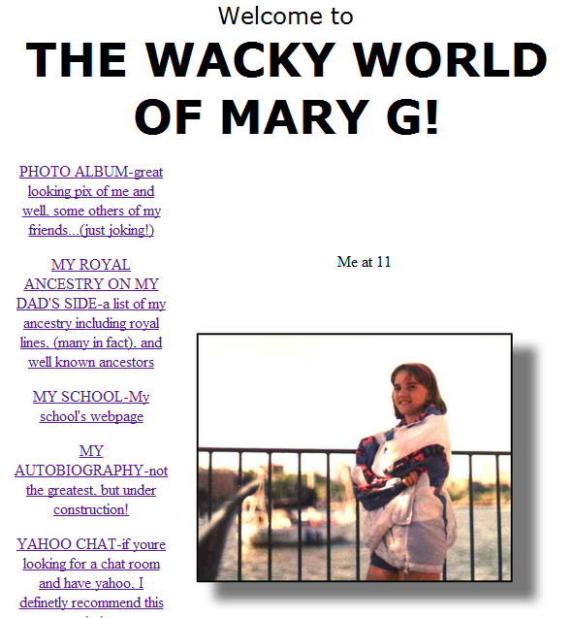
Though I have memories of my enterprising father using the discussion groups on USENET to do historical and genealogical research, I was too young to have personally experienced the discursive environment on the early USENET firsthand. The glory days of the medium had passed by the time I became old enough to appreciate such discussion. However, I did experience a different dimension of the Internet before social networking sites: early on, my tech-savvy father inculcated me with an interest in website design. By the time I was twelve, I had a modest website online with photos, a family history, an autobiography, and links to my school’s website.
Figure 1. The author’s website in 1999.
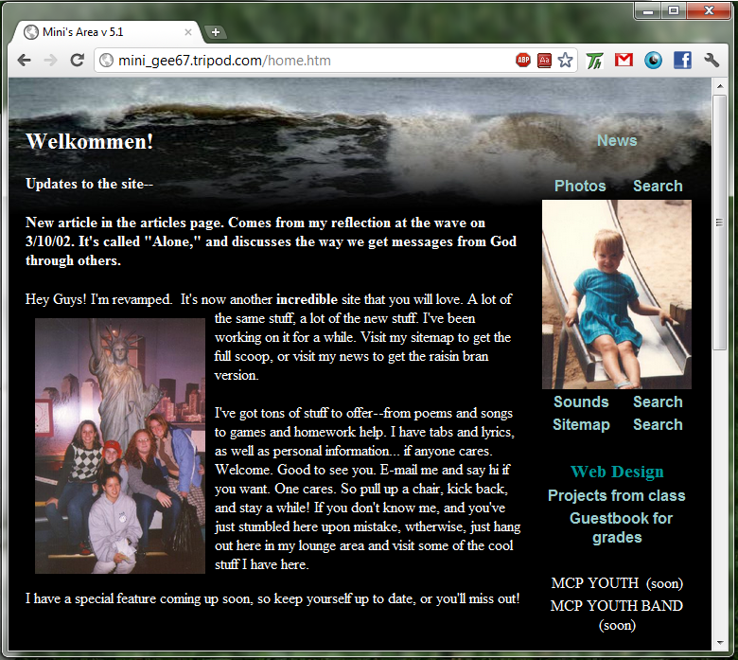
Then, in August 2002—about a year before the pioneering MySpace.com was launched—I took a course in web design at my high school. As one might guess, one of the assigned tasks for all students in the class was to build and manage a website. Of course, this was before the development in earnest of Web 2.0, so we relied on hand coding, CSS2, and early editions of Macromedia Dreamweaver to develop our humble websites. Each student had an account with Tripod, a service developed by college students before it was bought by Lycos in 1998 . Even in 2002—barely early enough to be fairly placed in the period of “the early Internet”—our websites were markedly unformulaic, especially in comparison to current profiles on social networking sites.
Figure 2. The author’s website in 2002.
Our sites were diverse and distinctive. Some of us included favorite quotes, journal entries, or photos. I shared miscellaneous poems I had written in my teen (read: embarrassing) years. A handful of students, presaging Mark Zuckerberg’s lucrative enterprise in Facebook, even had the ingenious idea of linking to each other’s sites! Nevertheless, aside from fulfilling our course requisites, there were few recurrent patterns across my classmates’ designs. Our choices about how to represent ourselves in cyberspace were themselves, in a way, part of our self-representation. This is visible in the difference between my two early websites. In 1998, as a gawky preteen, I had lived in “The Wacky World of Mary G!,” but my site in 2002 betrayed my assay at sophistication with the greeting, “Welkommen!” Furthermore, each of the amateur designers in my class chose not only which pictures (or poorly-written poems) to share—but we also elected whether or not to share them in the first place. Perhaps even more significant, we actively determined how we would interlace each of those sections to one another, drawing maps of ourselves, revealing our perceptions of how we situated our thoughts and our very selves in relation to one another.
Just as in Habermas’ account of the budding bourgeois public sphere, this early stage of online representation and discourse was not untouched by the private sphere of commodity exchange. In the same way that publishers sold books for a profit in the eighteenth and nineteenth centuries because there was a demand for such products, online startups had a clear financial motivation to provide free platforms for sharing images and essays (and, of course, embarrassingly bad poetry). Advertisers were eager to make use of the extremely low-cost promotional space, and to reach the ever-increasing number of people using the Internet. By 2000, online advertising revenues had reached over two billion dollars—up from just $30 million four years earlier .
Of course, our diverse, unique websites depended on these advertising revenues to subsidize the costs of webhosting. All of the students in my class took the free account Tripod offered, adding a pop-up window or a banner somewhere on our page. By the time that we were developing our sites, however, online advertising startups had suffered a major slump in revenues, a major component of the “dot-com bust” of 2000-2002 . Companies that had been eager to sponsor ads on websites like mine and those of my classmates had become skeptical of the efficacy of online advertising. What was the value of reaching the few readers of my unsophisticated website? What could even be advertised to them?

Personalized Advertising and Dividualization
Amidst the downturn, however, there was another development on the horizon. In the late nineties, two computer scientists at Stanford had developed a new algorithm for searching the web, resulting in a search engine that before long became wildly popular: Google. By 2000, Google founders Sergey Brin and Larry Page began to monetize the site by placing conspicuous, but simple text-based advertising within search results themselves. Early on, it was fairly straightforward: companies (such as, say, a shoe manufacturer) could pay to have ads placed in the results of certain searches (for instance, among other results for “sneakers,” or “stilettos”). Google has always insisted on their commitment to providing useful and relevant information—as CEO Eric Schmidt has declared, “[t]he primary mission of Google is to get you what you want, rather than what someone thinks you want” —and in keeping with this policy, the company made sure that sponsored advertisements were patently so. They identified each ad with a separator or shaded background and the disclaimer “Sponsored Links.” This emphasis on text-based, contextual advertising set Google apart from many other advertising schemes.
It was early in 2002, however, that Google really distinguished itself from the competition. Whereas similar mechanisms—like that of advertising rival Overture—displayed ads in order of the price paid for them, Google began to integrate an ad’s clickthrough rate in the algorithm that determined which ad would be displayed. The clickthrough rate served as a measure of the relevancy of the ad for other searchers, and relevancy, we recall, is Google’s doggedly avowed objective. John describes it as follows:
Imagine that three accounting firms are competing for the right to target their ads to the keyword "accounting services." And assume further that Accountant One is willing to pay $1.00 per click, Accountant Two $1.25, and Accountant Three $1.50. On Overture's service, Accountant Three would be listed first, followed by Accountant Two, and so on. The same would be true on Google's service, but only until the service has enough time to monitor clickthrough rates for all three ads. If Accountant One, who paid $1.00 per click, was drawing more clickthroughs than Accountant Three, then Accountant One would graduate to the top spot, despite his lower bid.
Of course, it didn’t hurt that, because Google had instituted a pay-per-click payment scheme, increasing click-through rates also directly increased revenue. Not only would Accountant One’s ad be more relevant for users—fulfilling Google’s goal of providing useful, relevant information—but it also made the company more money. This was markedly visible in Google’s yearly profit reports; in 2002, Google’s advertising revenues had shot to $411 million from $66 million in 2001. The next year, Google reported $1.4 billion in advertising revenue .
The key, then, was relevancy. How could Google find out what would be most relevant for its searchers? Certainly, it had extensive data about users’ search histories. Around this time, Google began to appreciate the real value of personal data. The collection of search histories was the first move in the development of contextual advertising and ad personalization. But why stop at the gold mine of data they were sitting on when the company could do even better? On April Fools Day, 2004, Google introduced what was to become one of their most popular, free services: Gmail . If Google’s database of search histories was a gold mine, Gmail was El Dorado. Eli Pariser points out that, though it was the sidebar of ads that would be displayed on Gmail that was most discussed in press reports about the launch,
it’s unlikely that those ads were the sole motive for launching the service. By getting people to log in, Google got its hands on an enormous pile of data—the hundreds of millions of e-mails Gmail users send and receive each day. And it could cross-reference each user’s e-mail and behavior on the site with the links he or she clicked in the Google search engine.
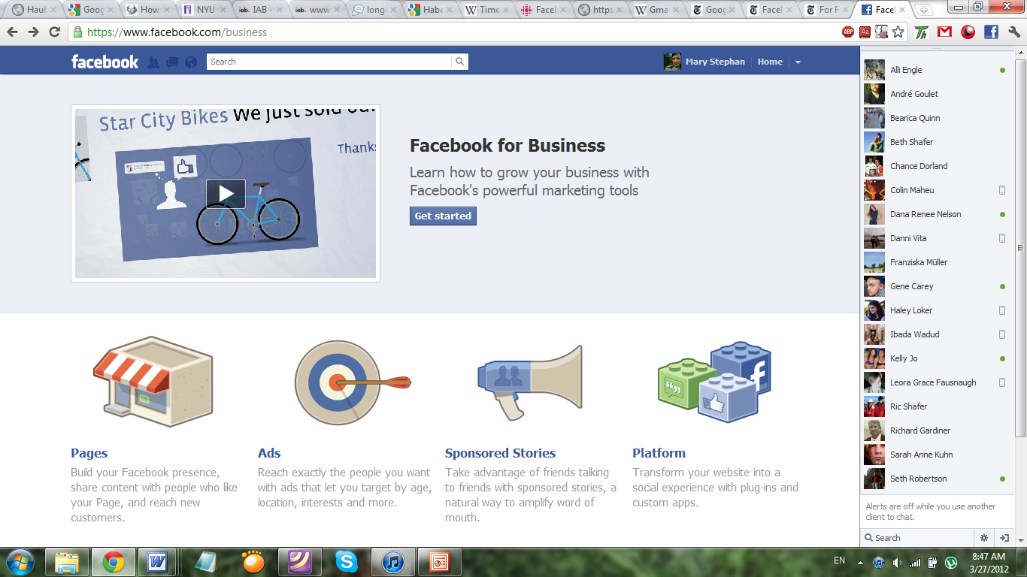
By April 2004, however, Google was already a step behind—though they didn’t know it yet. The company had a lockdown on personal information about search queries and related advertisement clickthroughs, but it had overlooked another, equally large data bank. Atop a mother lode of interpersonal relationship data stood Mark Zuckerberg, who, in February of 2004, had introduced an appealing, exclusive network for college kids. Inasmuch as his new platform enabled and encouraged members to link to each other, to interact and share photos and messages, all of those exchanges could be compiled in a powerful database of data points about users. If he ever was unaware of the power these data wielded, Zuckerberg would not remain so for very long. His company has unremittingly highlighted the potential for personalization in their materials for prospective clients—that is, for advertisers.
Figure 3. Facebook’s appeal to businesses.
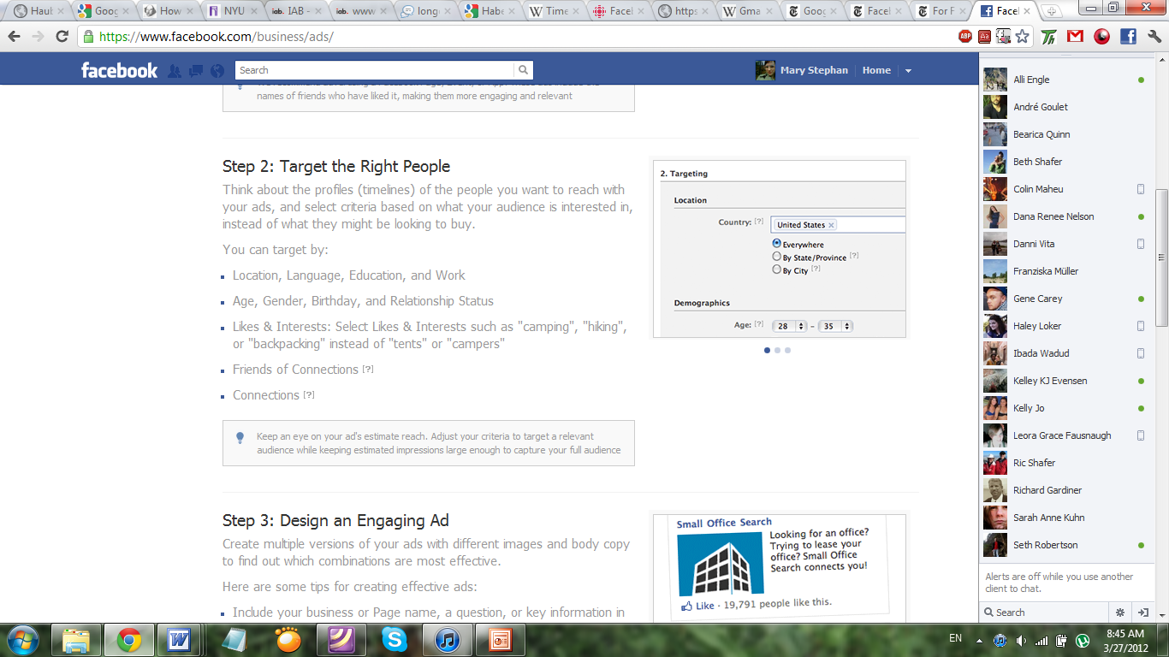
The mechanism by which Facebook acquires personal information, however, is different than Google’s in many ways. Whereas, early on, Google utilized their database of search queries to track users’ behavior, Facebook’s data set derives from the self-representations of users. As notices, there’s “a big difference between ‘you are what you click’ and ‘you are what you share.’” The structures of the sites betray this. When a prospective member signs up for a Facebook account, she is directed through a series of forms to complete with details about her past employment, her favorite movies, and even her sexual orientation. As a result, she no longer can introduce people to the “Wacky World of Mary G,” but instead she plays a more passive role in her self-representation. Rather than actively making every choice about her self-representation from a blank slate, she merely chooses whether and how to fill in the fields in Facebook’s standardized form. The self is refracted by Facebook’s template—it is represented by an aggregation of interests, shared media, and “friendships.” For their part, social networking sites encourage users to utilize these self-templates not simply because that makes them easier to manage, but because they generate mountains of extremely valuable user data.
Figure 4. A targeting mechanism for advertisers on Facebook.
This process is the quintessence of what Deleuze would have called dividualization. Today, he observes, people increasingly lose their status as “individuals”—that is, entities that are not dividual, but instead indivisible. The process of personalizing via “profile” exemplifies Deleuze’s observation that individuals “have become ‘dividuals,’ and masses, samples, data, markets, or ‘banks’” . Instead of being an indivisible whole, the entity of the self is constituted merely by the sum of ones favorite movies and employment history. “I” am no longer “me.” Instead, I become the constellation of my connection to other users in the network I call my “friends,” and the aggregation of photos tagged with me in them. I am the things that I Like.
laments that online tools “serve up fragments instead of considered whole expressions or arguments” or entities. In the very breaking up of ideas (or people) into bite-sized portions, he says, we forsake the most valuable elements of those things:
We know a little about what Aztec or Inca music sounded like, for instance, but the bits that were trimmed to make the music fit into the European idea of church song were the most precious bits. The alien bits are where the flavor is found. They are the portals to strange philosophies. What a loss to not know how New World music would have sounded alien to us! Some melodies and rhythms survived, but the whole is lost.
No online mechanism exhibits a more fragmentary representation of people than Facebook’s News Feed, which was launched in late 2006. An announcement on the Facebook blog explained the new tool. “Now, whenever you log in, you'll get the latest headlines generated by the activity of your friends and social groups” . The mechanism serves the most relevant fragments of friends’ personal information on a user’s Home page on Facebook, displaying details about the latest break up or a recent favorite song. As observes: “It’s hard to imagine a purer source of relevance.”
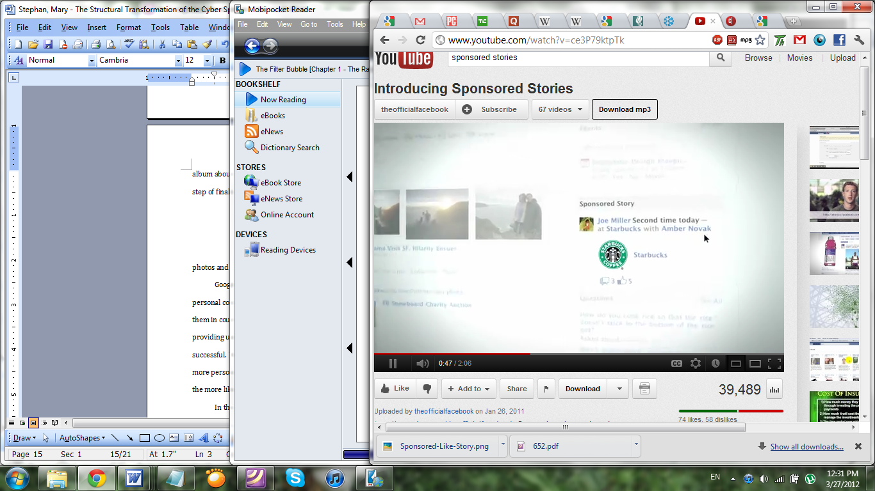
Users immediately organized in an outcry against the News Feed. Zuckerberg himself posted on the Facebook blog, assuaging users that the tool was simply developed to ensure “[y]ou don't miss the photo album about your friend's trip to Nepal” . It wasn’t until this spring, though, that Facebook took the step of finally integrating advertising directly into the News Feed, integrating friends’ photos and “Likes” into the ads . These simply augment the kind of work Facebook did with “Sponsored Stories,” whereby brands and corporations can pay Facebook to privilege status updates and posts related to their products. Dividualization becomes fully and patently privatized. Not only am “I” constituted by the things that I buy, but now corporations can pay to ensure that those consumptive self-fragments are disproportionately circulated. Notably, users are not able to opt out of this mechanism .
Figure 5. A sample “Sponsored Story” on Facebook.
Google has consistently tried to catch up with Facebook’s ever-expanding cache of personal connection data. The company’s first foray into social media, Google Buzz, nearly landed them in court. A new network, Google+, seeks to correct the mistakes the company made by providing users with more nuanced privacy tools; in its first few months, it has been fairly successful. Nevertheless, in each area of data collection, the quest is for relevancy. The more that ads can be tailored to the user through personalization, writes, “the more ads they can sell, and the more likely you are to buy the products they’re offering.” The use of templates of self-representation and communication facilitates the tailoring of ads to specific users. Dividualization—the fragmenting of individuals into data banks of, say, interests and search histories—is intimately related to personalization. The former directly facilitates the latter.
In the eyes of business firms, as we’ve seen, the personalization this information powers has a distinct advantage over public advertising—whether that happens on a billboard or on a banner ad on Tripod. Personalized messages are much more effective than those that target general demographics. Personalization allows the message to be tailored to be relevant for the viewer of the advertisement. Making messages relevant through personalization, however, implies the extrication of issues that might call the user to consider the common concern—issues that should be encountered and discussed in a public. As presciently wrote in 1989, there has been a
substantial resegmentation of communication fostered by many uses of computer technology. Computer-assisted direct mail campaigns, for example, may be a means for a politician to subvert public discourse by tailoring messages to different mailing lists, thus effectively saying different things to different groups of voters or potential donors.
The result of the invasion of competition between private interests in the public sphere, according to Habermas, is the loss of its “communal basis.” Consequently, individuals fail to get a comprehensive view. Even ostensibly public communication becomes private. As we saw above, when the rules of the market are grafted onto the rules of the public fora, discourse is “replaced by consumption, and the web of public communication [is] unraveled into acts of individual reception, however uniform in mode” . Economic incentives drive personalization—and the dividualization that underpins personalization—and public communication suffers as a result. It is hard to imagine a purer platform for “individual reception” than the News Feed. Habermas later quotes Bahrdt, who laments that citygoers no longer receive “an overview of the ever more complicated life of the city as a whole in such a fashion that it is really public for him. The more the city as a whole is transformed into a barely penetrable jungle, the more he withdraws into his sphere of privacy which in turn is extended ever further” . When the advertising and information that we receive is so fully personalized, our prospects of discussing public matters—as well as our opportunities to personally encounter difference—diminish.
However, one of the most insidious consequences of the personalization process is not simply the segmentation of reality, but the development of information ecologies that tend to distort reality altogether. This is epitomized in the development of Facebook’s “Like” button.

Like… +1
In the presses of the mid-twentieth century, wrote that there emerged “a pleasant and at the same time convenient subject for entertainment that, instead of doing justice to reality, has a tendency to present a substitute more palatable for consumption and more likely to give rise to an impersonal indulgence in stimulating relaxation than to a public use of reason.” Similarly to the ways the monetization of the presses in the twentieth century affected the content of the books, we can discern a parallel development in the springing from the establishment of the Like button.
Launched in 2009, the “Like” button is a small icon users can press to express a fondness or appreciation for some piece of data—a photo, a status update, or even a product. According to the Facebook team, “‘Like’ is a way to give positive feedback or to connect with things you care about on Facebook” . As a data gathering tool, the “Like” button might be the data point par excellence—a binary switch denoting a positive connection between any two pieces of other data. It figures prominently in Facebook’s new advertising scheme, whereby friends’ “Likes” can be sponsored by corporations and displayed as ads.
The name of the device is not insignificant. For a time, the company had considered calling it the “Awesome!” button, but thought wiser of it and changed it to “Like” . perceptively suggests that the choice of the word “Like” is “a small design decision with far-reaching consequences: The stories that get the most attention on Facebook are the stories that get the most Likes, and the stories that get the most Likes are, well, more likable.” Why not, instead of “Awesome!” or “Like,” might the company allocate space for an “Important!” button? Simply put, the company’s objective is to keep people using the site, and to continue to make connections between people and their data. This is facilitated by the exchange of pleasant, not important, content—or, as Habermas noted, content that is “more palatable for consumption,” rather than content that challenges readers. “Social media is all about building networks, being accepted, being ‘liked’, sharing information…positive things,” affirms blogger Paul . Facebook wants to generate as many clicks on links as possible, and it knows full well that people are immensely more likely to follow links to posts others have “Liked,” rather than media that are “Important!”
“Like” has another advantage: as a transitive verb, it performs the essential connecting function even more effectively. As well as “Liking” news stories and notes, users can be persuaded to “Like” Coca-Cola much more than to call it “Awesome!” This transitive function has also contributed to the integration of Facebook with virtually every other large site on the World Wide Web. As of September 2011, 905,000 websites had incorporated the Like button somewhere on their site .
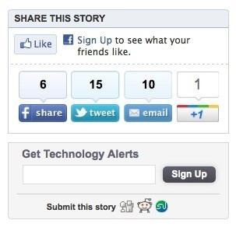
Google, of course, followed suit. With the launch of Google+ in 2011, the company offered a “+1” button, which performs largely the same function, albeit with more impersonal language. These buttons, along with Twitter’s “tweet” button, and many other share buttons—from Tumblr, Digg, and Reddit—are present on virtually every corporately owned website, and countless personal blogs. They allow information to be passed on and integrated with data stores on each of those respective social networks.
Figure 6. Like and other buttons on a third-party website.
Because people want to generate content that will be Liked and shared (or +1’d, or tweeted), the very information that is generated and published in the first place privileges a certain, particularly rosy outlook. “The laws of the market have already penetrated into the substance of the works themselves,” laments, “and have become inherent in them as formative laws.” The insight undoubtedly translates; it is perhaps the most significant reason that Facebook chose not to incorporate the “Dislike” button that was clamored for by millions of users. “Like” is a social lubricant; it encourages connection. “Dislike,” on the other hand, is socially corrosive. Because Facebook is cognizant of this, the dislike button will assuredly never be instituted. The content of communication, as a result, is fundamentally altered—it is sanitized. After all, many fewer people feel comfortable “Liking” something such as a news article detailing human rights abuses, or a recent natural disaster, rather than “Liking” more positive reports.
However, the problems with “Like” lie not only in the collective sharing of information, but also on the personal level. The algorithms used by Facebook (and Google+) are developed to give us information that we might also be prone to “Like.” The mechanism doesn’t simply facilitate the creation of content that is generally likeable; it also provides us with information and opinions that are personally likeable as well. As a graduate student in politics, I may be served a platter of status updates and photos about the latest health care debate, or a recent piece of news—which I would quite likely “Like”—rather than tidbits about, say, the latest sports game. thus sardonically exalts the personalizing technologies for their capacity to make us feel good. “We’re never bored. We’re never annoyed. Our media is a perfect reflection of our interests and desires… It’s a cozy place, populated by our favorite people and things and ideas.” Nothing has ever been able to facilitate such personal customization as the personal computer. Perhaps this is why Neil surmised that, “[i]f the press was, as David Riesman called it, ‘the gunpowder of the mind,’ the computer, in its capacity to smooth over unsatisfactory institutions and ideas, is the talcum powder of the mind.” In being offered things we might like by the network’s algorithms, we are often given things that are familiar to us; after all, as we know, personal encounter with difference can often be uncomfortable. People who are uncomfortable might have the inclination to log off—that is, unless they are too entrenched in the network, due to what some technologists call “network lock-in.”

Network Lock-in
One of the essential steps in the process of networking and data aggregation is so-called “lock-in.” Lock-in is the phenomenon by which a particular network or service is so entrenched in society that its users are invested in it to the point at which they refuse to switch to other, better networks or services. It would simply be too arduous to do so. encourages us to conjure the idea of making the switch:
If you’re a Facebook member, think about what it’d take to get you to switch to another social networking site—even if the site had vastly greater features. It’d probably take a lot—re-creating your whole profile, uploading all of those pictures, and laboriously entering your friends’ names would be extremely tedious.
This was the genius stroke of the company. Once it succeeded in getting college students to “buy in” to the network, and consequently establishing membership an ostensible social necessity, the network became able to glean countless data from its users with little disturbance. In spite of what the network does—say, require users to relinquish all ownership of any data posted on the site, as they did in February 2009 —the cost may be too high for users to switch to a competing service.
The phenomenon is also known as “Metcalfe’s Law,” which surmises that the value of a network increases exponentially with every additional user. Seth borrowed a popular illustration of the law when he rearticulated thus: “the more people who have a fax machine, the more fax machines are worth.” Facebook, just like fax machine, is useless to a single person. Its value derives from the connections it comprises. The more connections hosted on the service—a number that increases exponentially as the number of users increases—the more value to each user. In those terms, it’s not Facebook’s 845 million users that make the network valuable—it’s 100 billion friendships the company reports are incorporated in the service . Furthermore, the site has become firmly embedded in our online ecologies. Few visit sites that are not sponsored by significantly large corporations or institutions and most of these significant sites have business deals with Facebook that facilitate the exchange of information between the social network and the site via mechanisms like the Like button.
The presence of network lock-in has led sociologist danah boyd to suggest that we begin to think of Facebook as a utility. The conception is certainly not unfounded—Zuckerberg himself has used the language. But suggests that Facebook’s status as utility suggests a future the company might resist: “Utilities get regulated.”

Restoring democratic possibilities
Habermas was not optimistic about the possibility of reversing the conflation of public and private. The domination of moneyed interests in the distorted shadow of the public sphere does not provide much opportunity for a restoration of the disinterested, democratic discourse that first appeared in those early coffeehouses. Instead, it propagates the status quo:
Were one to compress into one sentence what the ideology of mass culture actually amounts to, one would have to present it as a parody of the statement, “Become what you are”: as a glorifying reduplication and justification of the state of affairs that exists anyway, while foregoing all transcendence and critique.
To some degree, we can see similar developments over the last few decades in the emergence of the advertising industry online. Pariser called this the “You Loop”—the cycle whereby users, who control their media via clickstreams and personal data, are then reinforced by that personalized media. If I “Like” an NPR story I see on my News Feed, I’ll get more of them. My interest in NPR is amplified—possibly, to the detriment of my exposure to, say, Fox News stories. In a sense, as Habermas wrote, I become who I am.
The encroachment of markets upon this medium feeds this feedback loop. The reason that personalization is so widespread today is not simply because it is what users want, but because it generates revenue for online corporations like Google and Facebook. Insofar as those companies are motivated to provide us with information and advertising we are prone to click on, personalization exacerbates the phenomenon of homophily—the tendency of people to seek out like-minded others, or for “birds of a feather to flock together.”
Nevertheless, offers one prescription: “freedom of assembly and association,” he insists, “needs a guarantee of active promotion.” Corporations are so monolithic and so “publicistically effective” that they need present and active alternatives to challenge their solidified position in the market, and in the public in general. The activities that were encouraged and safeguarded in salons and in novel and journal readership must be actively redeveloped.
This involves not only challenging the corporations themselves, but also challenging the homophilic tendencies they exploit in their pursuit of revenues. Because, as writes, “[h]omogeneous networks occur regularly,” we must put a priority on “promoting greater heterogeneity.” This may involve demanding that the algorithms that are used to curate the information we are exposed to are transparent. It also requires that we, as users, demand personalization that does not broadly extricate difference from our media ecologies. We must also, as wrote, “nurture a public discourse in which these various groups and individuals may consider their respective and collective wants and possibly modify them.” This entails our commitment to reaching beyond simple consumption and “individual reception,” into a more public arena. We ought, as Young encourages, to aspire to communicate across lines of difference with the purpose of cultivating mutual understanding—as did the earliest users of USENET. To those ends, perhaps we ought to join boyd’s call for the regulation of social utilities as they increasingly demonstrate the characteristics of more traditional utilities. Until then, change can come about only to the degree that users demand for it within the networks.

In fact, shared the first details about his invention on USENET.
The Department of Defense project from which the Internet as we know it originated.
Because, as reminds us, “the subject is not a unity, it cannot be present to itself and know itself,” an important component of this early mode of self-representation was that it was prone to change. Not only was there diversity across my classmates’ personal sites, but each student’s site also changed over time.
Google nearly sold much of this data to the advertising service DoubleClick. This was Google’s fallback plan, according to founder Brin, if their monetizing mechanism fell through . Ironically, the tables were turned in late 2007, when DoubleClick itself was acquired by Google.
Many of those whose sites are not either on Facebook proper or connected to it by means of cookies or a Like button utilize Google’s AdSense to generate revenue to support the site.
"We think of ourselves as a utility," he once told Viacom CEO Tom Freston . It was not the first time he had compared Facebook to a utility .

